

# Apple ipad Air (4th Generation) 10.9 inches

## Type of device: Tablet

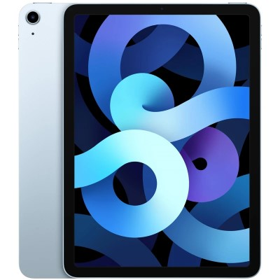

Actual Display Size : 10.9 inches

Operating System : Apple IOS

Version Number : iPadOS 14.1

Year of Release : 2020

Average Price : $1014 as of 26 November 2020

Internet Access : Wi-Fi Only

## Accessibility Features:

### Cognitive

* Additional Instructions
* Copy and Paste
* Flicker Free Display
* GPS
* Photo Telephone List
* Screen Timeout Disabled
* Simple Instructions
* Simple Reminders
* Simplify Display

Voice Notes

### Hearing Impairment and Deaf

* Allows for sign language communication
* Bluetooth or Wi-Fi
* Closed Captioning
* Front Facing Camera
* Text Messaging/SMS
* Vibrating Alerts - Adjustable
* Video Communications - Two-way

Visual Alerts - Incoming Calls

### Vision

* Accessibility APIs supported
* Battery Alert - Audible
* Bluetooth or Wi-Fi
* Braille Display Support
* Brightness Adjustable
* Dictation / Speech-to-Text
* High Contrast Mode
* Personalised Shortcuts
* Power Cue
* Screen Magnifier
* Screen Reader
* Text Size Adjustable
* Text Style Adjustable
* Voice Control /Personal Assistant

Voiced Menus

### Speech

* Allows for sign language communication
* Bluetooth or Wi-Fi
* Messaging Options - Email
* Messaging Options - IM
* Predictive Text
* SMS Personalisation and Reuse

Voice amplification

### Physical

* Bluetooth or Wi-Fi
* Dictation / Speech-to-Text
* Flat Back for Table Top Operation
* Gesture Based Navigation
* Predictive Text
* Reduced hand movement option
* Speaker-phone option
* Stylus or Prosthetic Device support
* Switch control option
* Visible Focus Indicators
* Voice Control / Personal Assistant
* Voice Recognition for Accessing Features

Voice Recognition for Dialling

## How and where to get it from?

You can buy this phone from [Apple](https://www.apple.com/au/shop/buy-ipad/ipad-air/256gb-silver-wifi), [JB Hi-Fi](https://www.jbhifi.com.au/?q=Apple%20iPad%20Air%20Wi-Fi%20%5B4th%20Gen%5D&hPP=36&idx=shopify_products&p=0), [Betta Home Living](https://www.betta.com.au/catalogsearch/result/?q=Apple%20iPad%20Air%20Wi-Fi%20%5B4th%20Gen%5D), [Kogan](https://www.kogan.com/au/shop/?q=Apple+iPad+Air+Wi-Fi+%5B4th+Gen%5D), [Harvey Norman](https://www.harveynorman.com.au/apple-ipad-air-wi-fi-64gb-4th-gen-space-grey.html), and other retailers.

## More information is available on:

[Apple iPad Air website](https://www.apple.com/au/ipad-air/specs/)

[Apple iPad Air (4th gen) user manual](https://manuals.info.apple.com/MANUALS/1000/MA1959/en_US/ipad-air-4th-gen-ipados14-info.pdf)

[Apple Accessibility Website](https://www.apple.com/au/accessibility/ipad/)